**How to Plot with Matlab**

go into this folder



Open **TestEulerEKF.m**  
and **TestLPF.m**

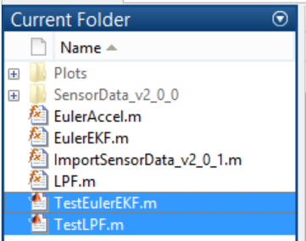

Select **TestLPF.m** > click **Run**

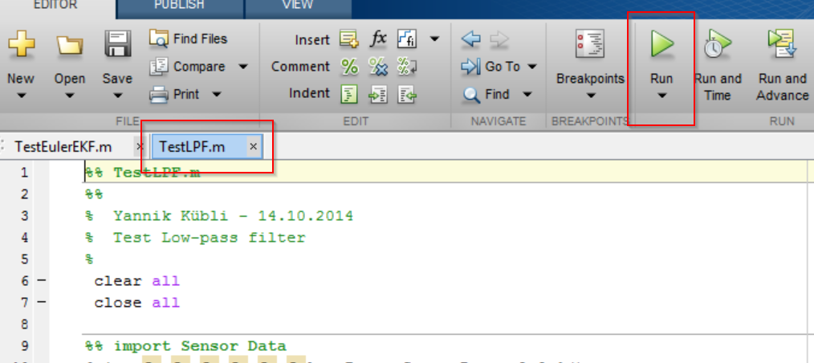

Select **TestEulerEKF.m** > click **Run**

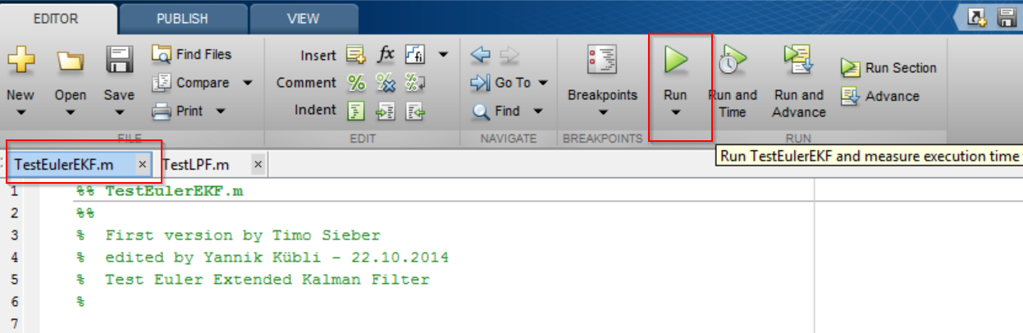

**Voilà**

